SESNSORS FOR PROTOTYPE
- ENCODERS
OPTION 1 - Pro-Range 2500 PPR ABZ 3-Phase Incremental Optical Rotary Encoder
Price-₹ 3,972.00

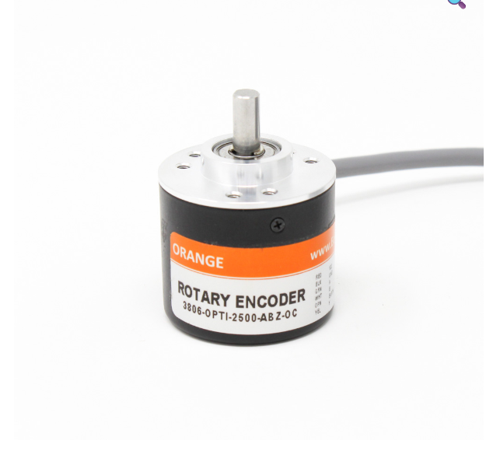
Product link - https://robu.in/product/orange-2500ppr-abz-phase-incremental-optical-rotary-encoder/
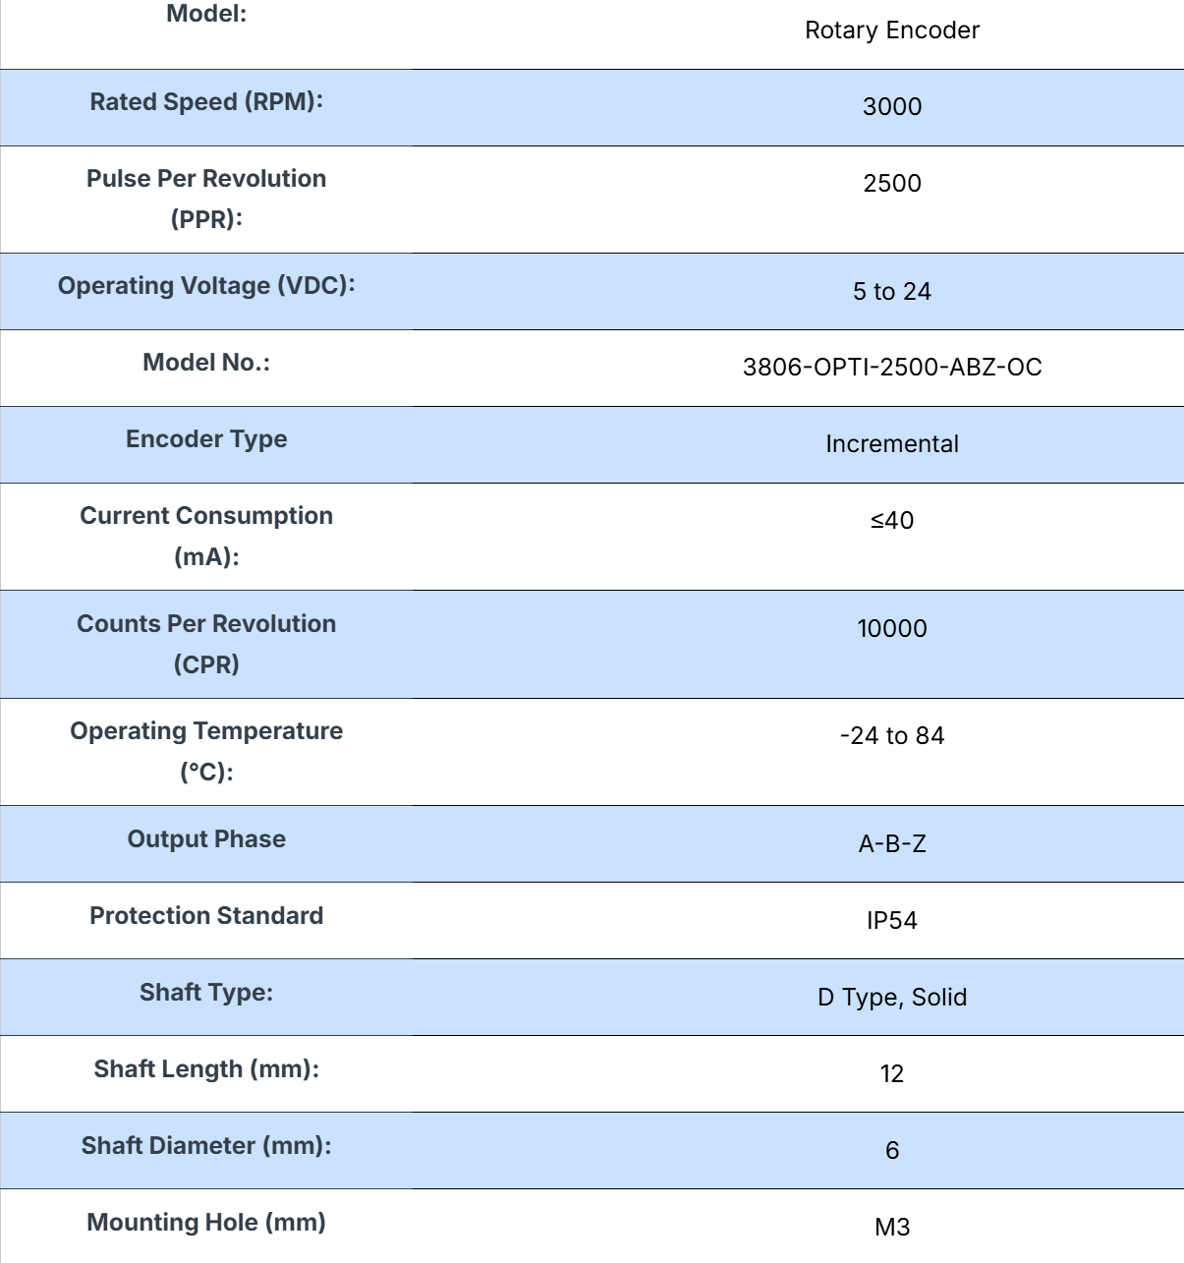
OPTION 2-Pro-Range (E38S6G5-5000Z-G24N) Rotary Incremental Encoder – 38mm, Photoelectric, ABZ 3 Channels
PPR -5000
Price- Rs.2422
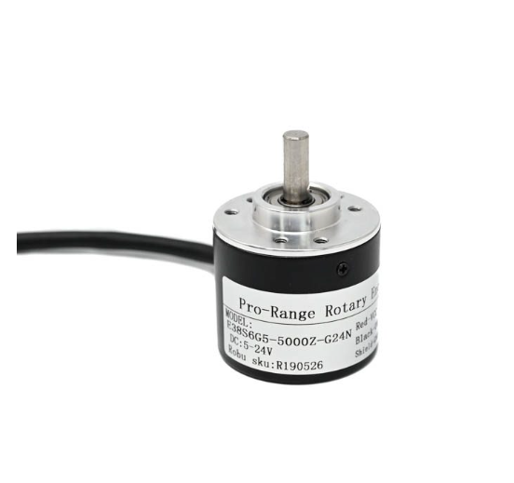
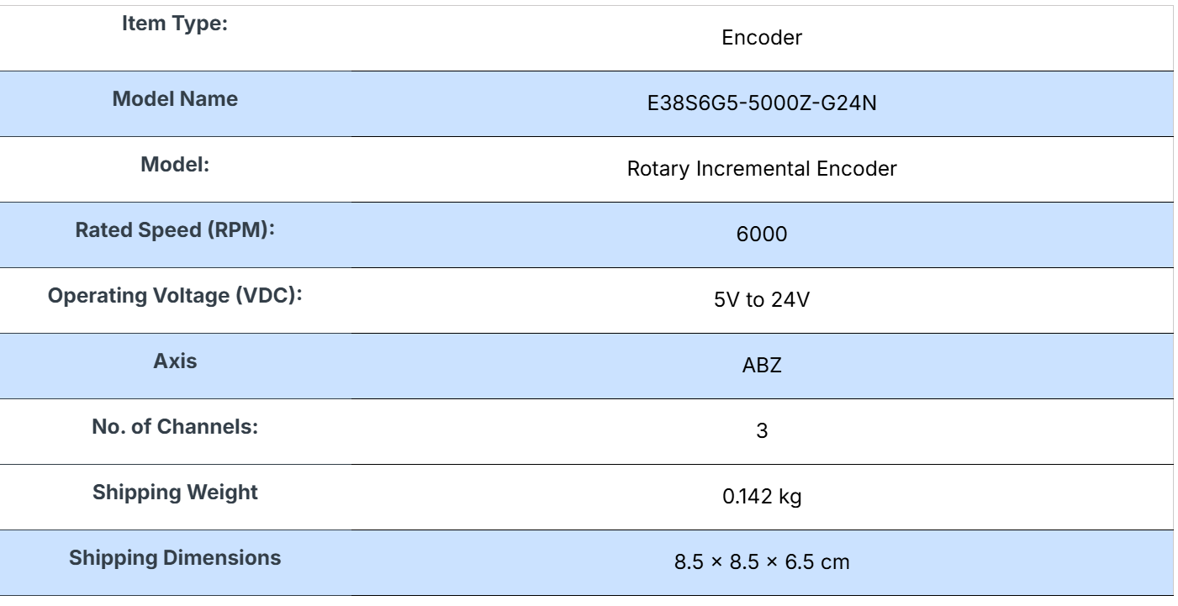
Product link - https://robu.in/product/pro-range-rotary-incremental-encoder-38mm-photoelectric-abz-3-channels-5000-ppr-e38s6g5-5000z-g24n/#tab-specification
Datasheet- https://robu.in/wp-content/uploads/2024/12/E38S6-1.pdf

- CAMERAS
Option 1 - ZED 2i Stereo Camera * SAME ONE IS USED BY IITB*
Price-529 USD (including shipping)

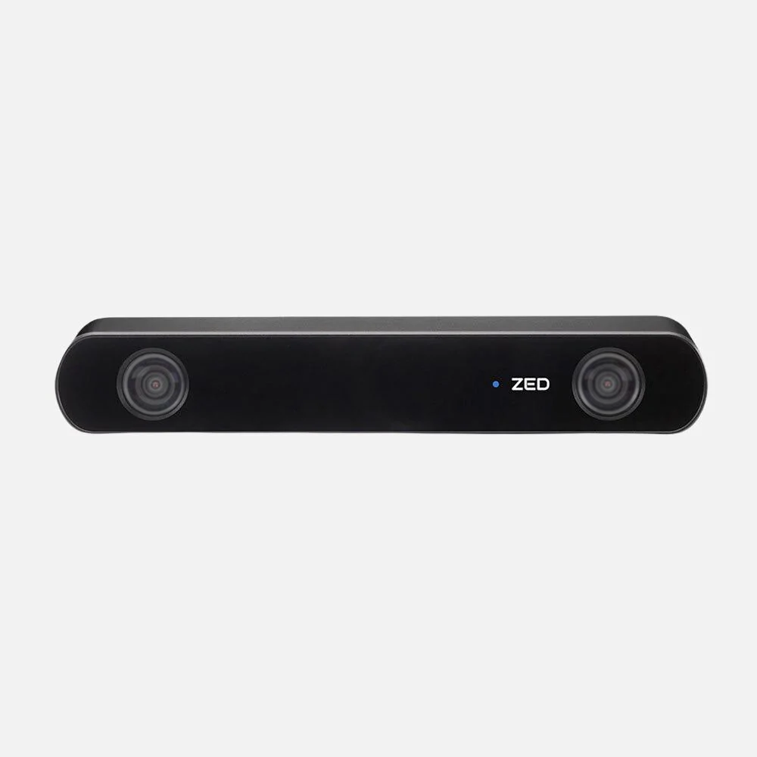

- Dual high-resolution RGB sensors with a wide 110° field of view.
- Integrated IMU, barometer, magnetometer, and temperature sensor for robust environmental awareness.
- Neural depth engine enabling precise obstacle detection and 3D mapping.
- Modular design with interchangeable lenses and an optional enclosure for IP66 protection.
- Compatible with NVIDIA Jetson and other edge platforms.
- Ideal for autonomous navigation, object tracking, spatial analytics, and mixed-reality
- Neural Depth Sensing
- Spatial Object Detection
- Built-in Next-Gen IMU, Gyroscope, Barometer & Magnetometer
- 120° Wide-Angle FOV
- All-Aluminium Frame with Thermal Control
- Optional Integrated Polarizer for reflection removal
- IP66 protection from water and dust
- Secure USB Type-C connection

*MORE DETAILS ARE AVAILABLE ON THE WEBSITE*
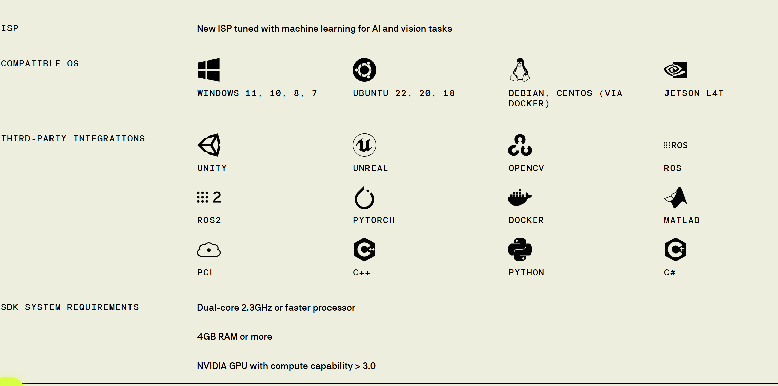

DATASHEET-https://cdn.sanity.io/files/s18ewfw4/staging/c059860f8fe49f3856f6b8da770eb13cc543ac2c.pdf/ZED%202i%20Datasheet%20v1.2.pdf
PRODUCT LINK -https://www.stereolabs.com/en-in/store/products/zed-2i

OPTION 2 - Stereolabs ZED Mini Stereo Camera (RECOMMEND)
PRICE-429 USD (INCLUDING SHIPPING)
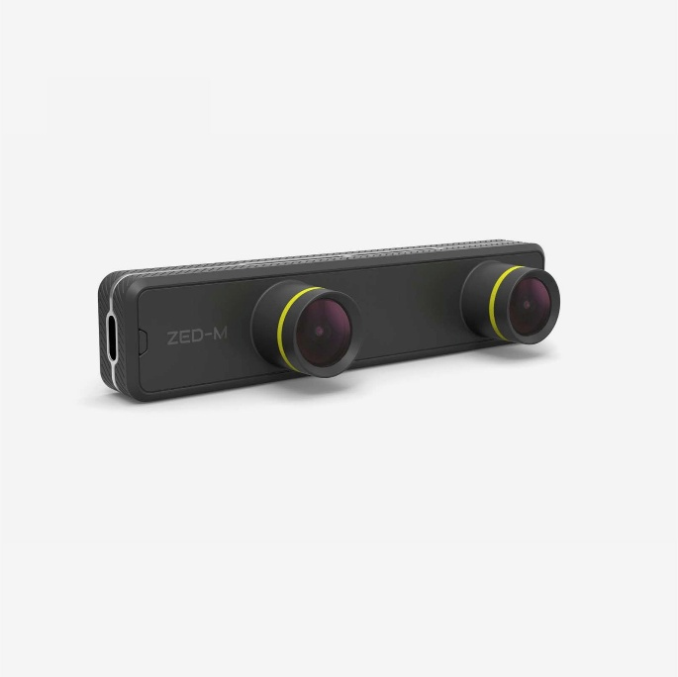
Product Features
- Built-in 6DoF IMU for accurate motion tracking.
- HD depth sensing with new Ultra mode.
- Small form factor with 6.5cm eye separation.
- Aluminium frame for improved robustness and integration.
- USB Type-C for high-speed data transfer and improved reliability.
- ZED SDK for application development.

System Requirements for SDK
- Dual-core 2.3GHz or faster processor
- 4 GB RAM or more
- USB 3.0

System Requirements for AR
- Quad-core 3.0GHz or faster processor
- 8 GB RAM or more
- NVIDIA GTX 2070 or higher

DATASHEET-https://cdn.sanity.io/files/s18ewfw4/staging/ebcd46896092d1ee6212b7f4d81aaa1c479c2440.pdf/ZED%20Mini%20Datasheet%20v1.1.pdf
PRODUCT LINK- https://www.stereolabs.com/en-in/store/products/zed-mini
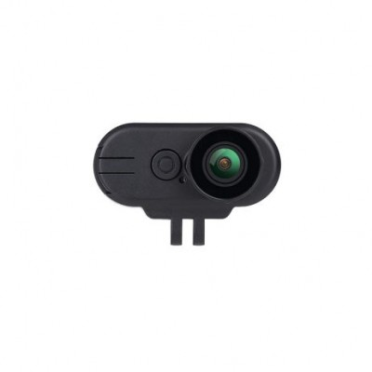
Hawkeye Thumb 4K
*CAN BE USED ALONG WITH THE STEREO CAMFOR MONOCULAR VISION PIPELINE ALSO CAN BE PURCHASED WHICH IS SAVED ON ZED MINI *
PRICE - Rs.6604.00

PRODUCT LINK- https://www.electropi.in/hawkeye-thumb-4k

